Basic Linux command task on day 5
- Create user with name Techie and provide sudo access to user.
User created in the below screen shot; I have used command badname as it is not allowing to create the name.
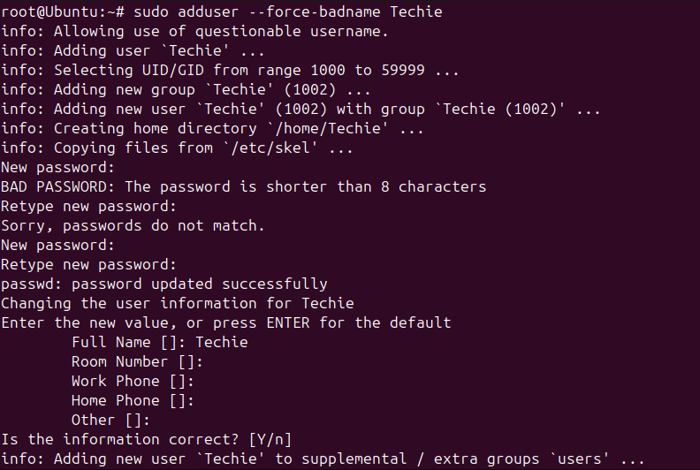

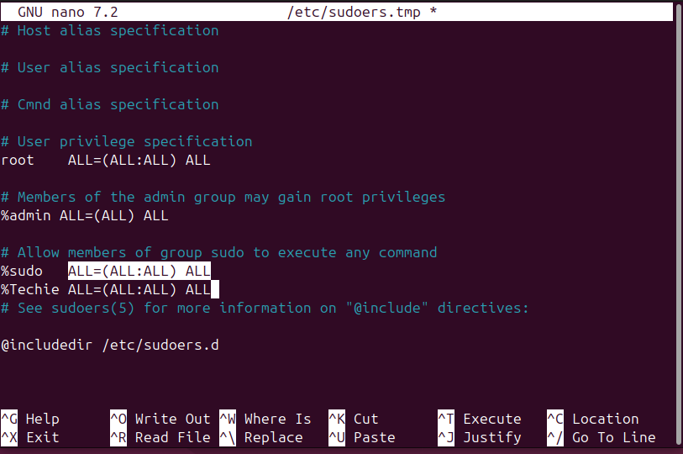

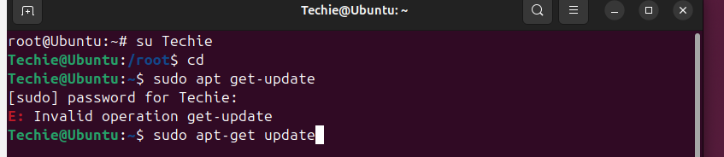

- Navigate to the home directory.
Used command cd ~


- Create a new directory.
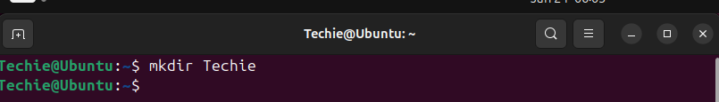

- List the contents of a directory.
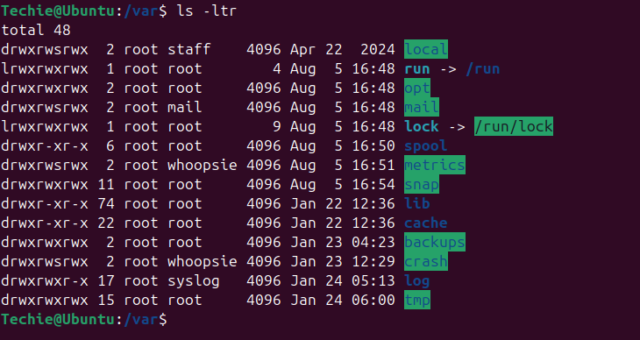
- Change the current directory.
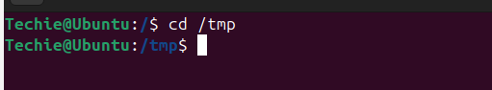

- Create a new empty file.
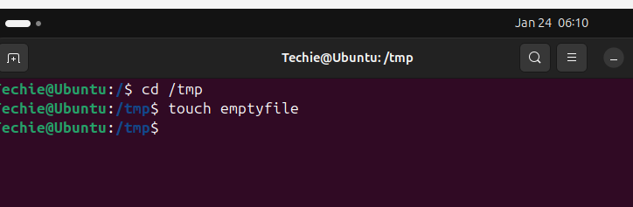

- View the contents of a file.

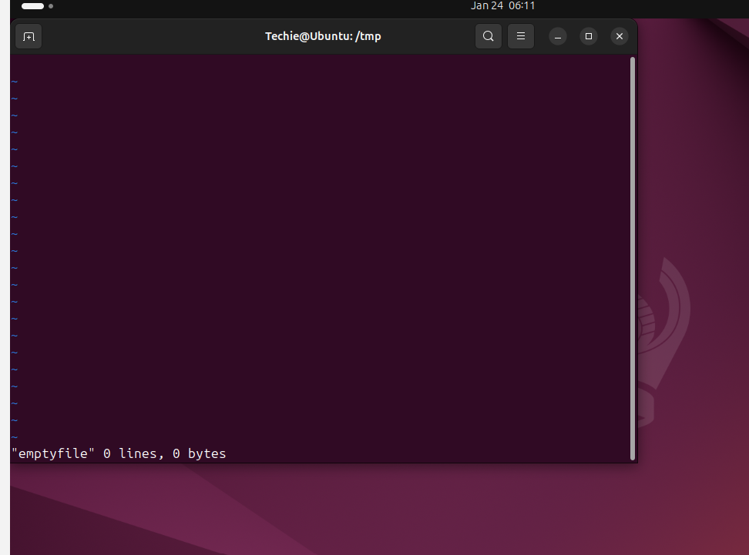

- Copy a file to another location.
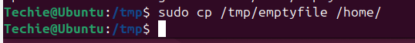

- Move a file to another location
- Rename a file
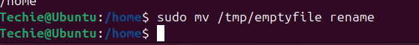

- Delete a file
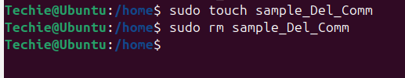

- Grant or revoke permissions on a file or directory
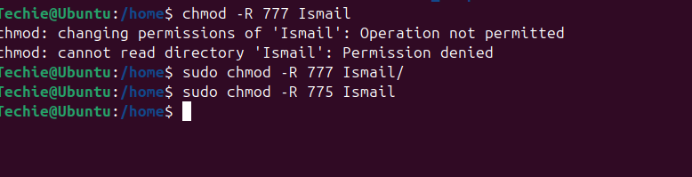

- View the current date and time.
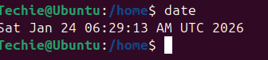

- Check the system uptime

- View the running processes.
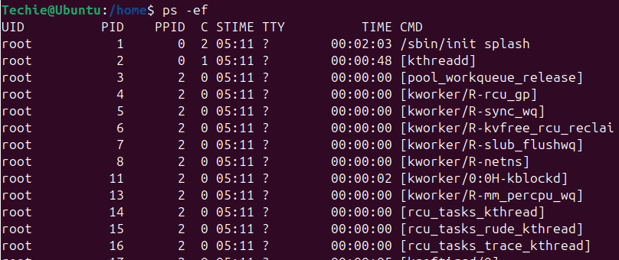

- Kill a running process.
- Install a package using the package manager (e.g., apt or yum).

- Update the system packages.
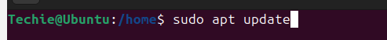

- Create a symbolic link.
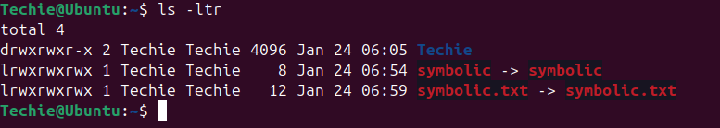
- Search for files using the find command
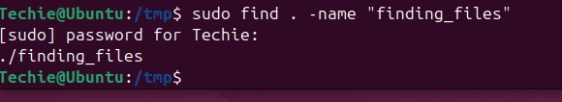

- Compress and decompress files using tar.
Command to compress as shown below in screen shot
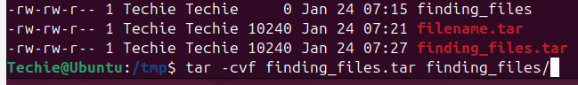
Decompress files
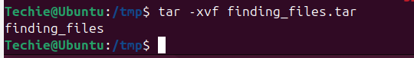
- Monitor system resources with top or htop.

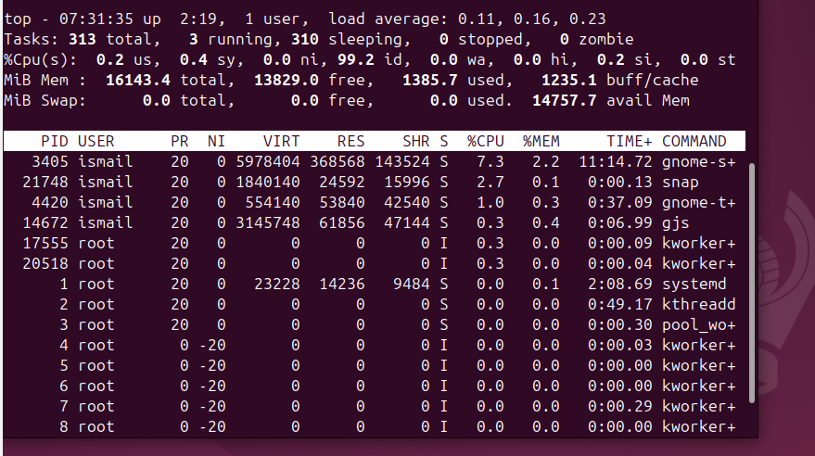
- Create and manage user groups.
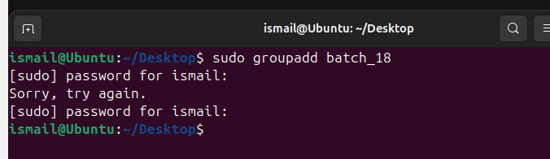
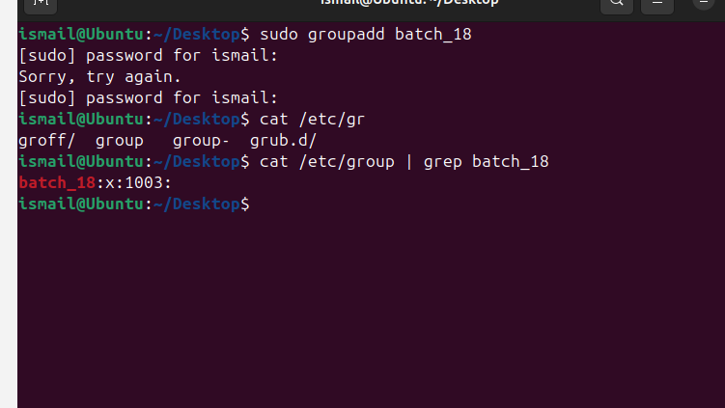

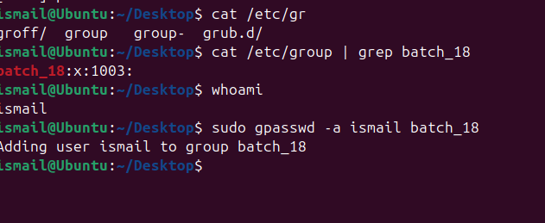

- Set up SSH password less authentication.
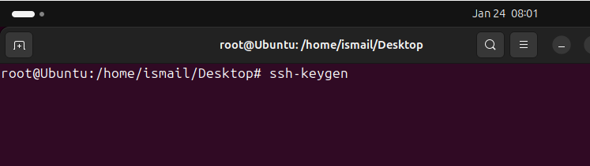
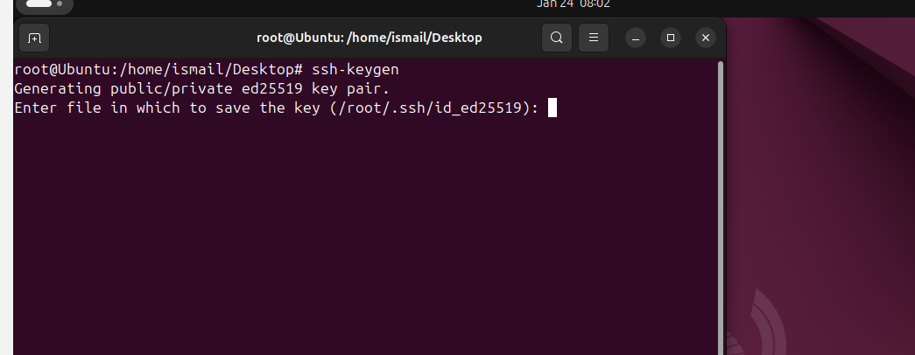
Private key generated in the above screen shot

Please check the public key in below screen shot.
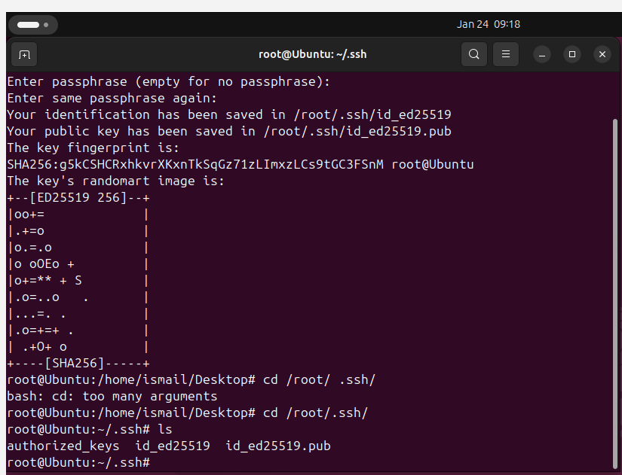

Ssh# ssh-copy-id -i /root/.ssh/id_ed25519.pub root@
Client-server
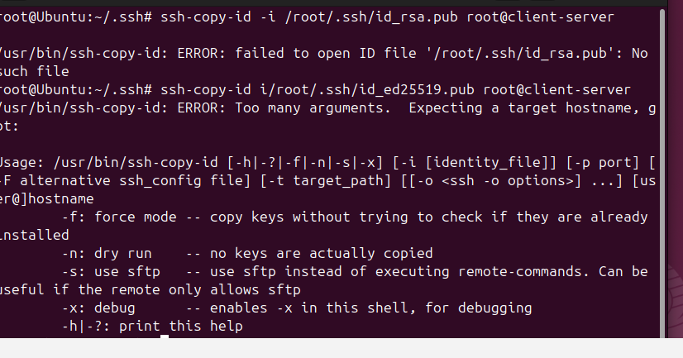
- Monitor log files using tail or grep
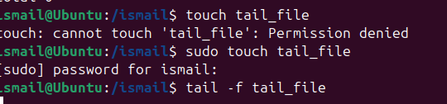
- Set up a web server (e.g., Apache or Nginx).
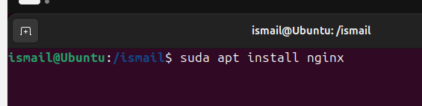

- Configure and secure a MySQL Database
Enable universe repository
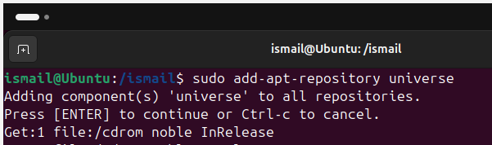
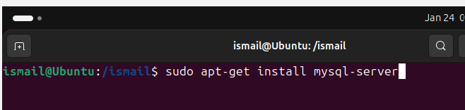
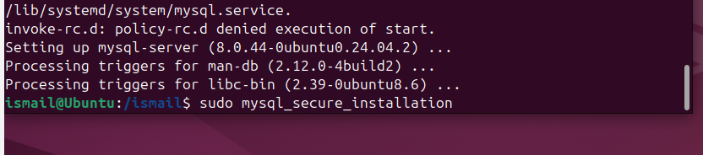

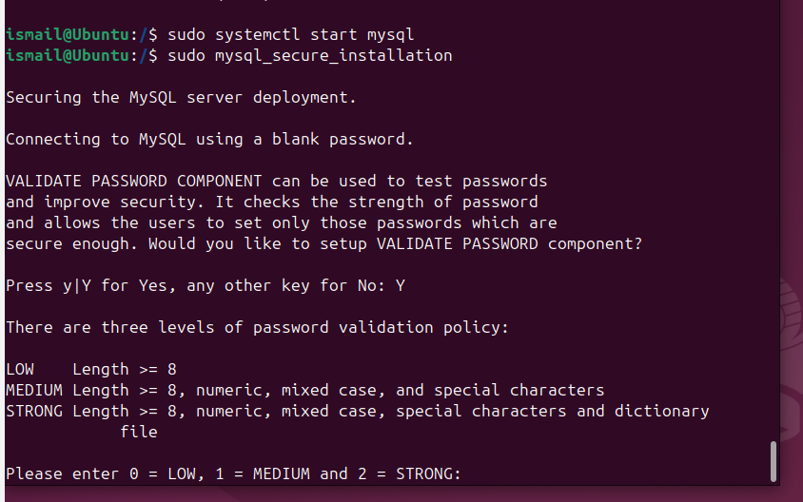

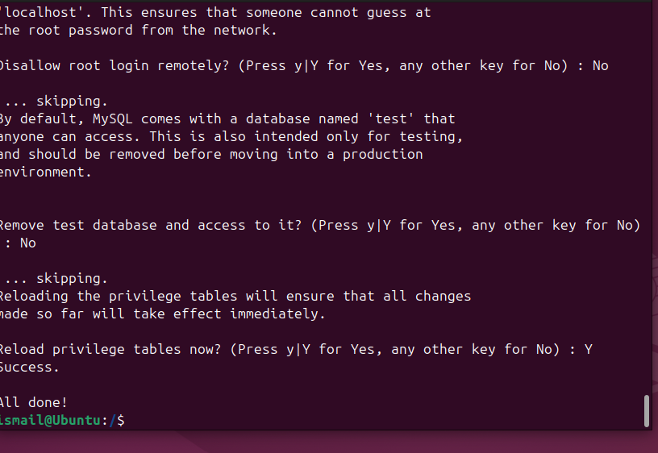

- Set up a Application Server (e.g., Apache Tomcat)
Unable to setup mozilla
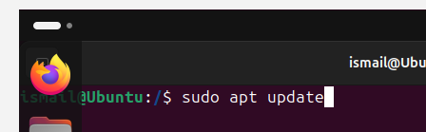
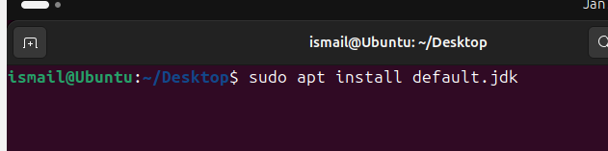

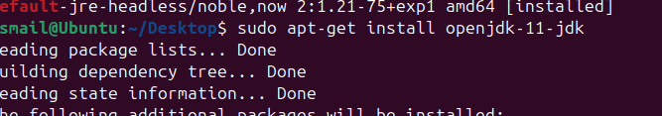
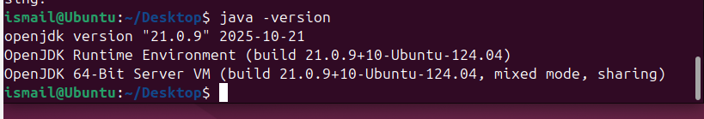

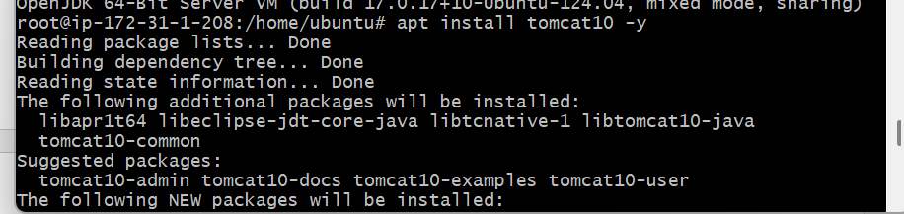
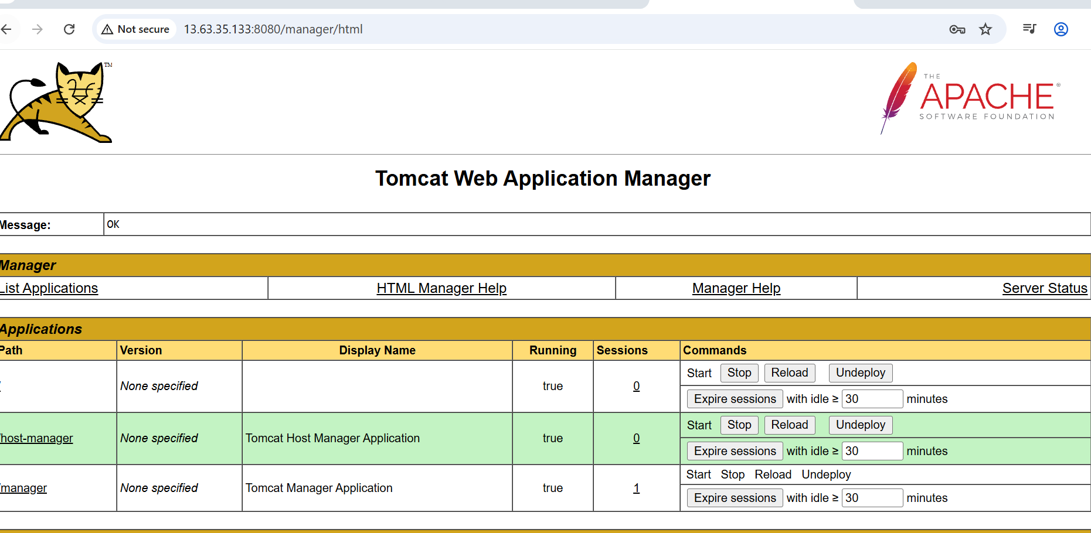
- create a service file for Apache Tomcat.(Should execute by using systemtctl command)
- Print specific columns from a delimited file.
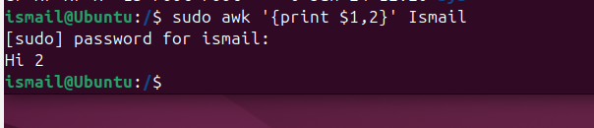

- Filter and print lines based on a specific pattern or condition.


- Calculate and print the average, sum, or other statistics of a column.
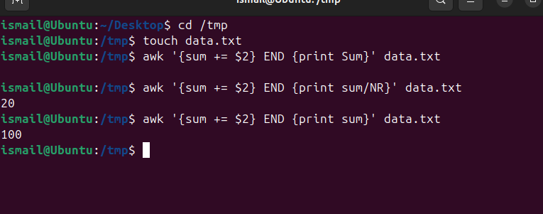

- Perform string manipulation, such as extracting substrings or changing case.
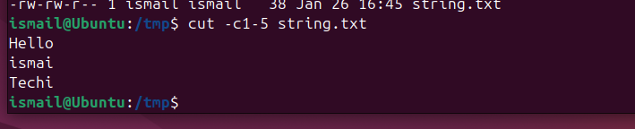
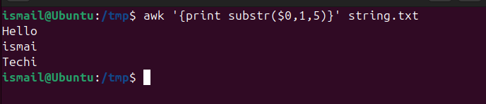

- Count the occurrences of a specific pattern in a file.
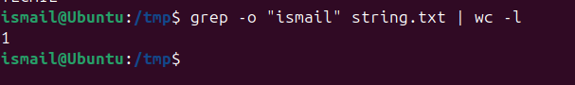
- Sort lines based on a specific field or column.


- Merge multiple files based on a common field or column.
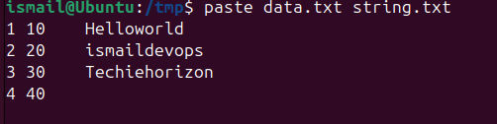
- Substitute text in a file using search and replace.
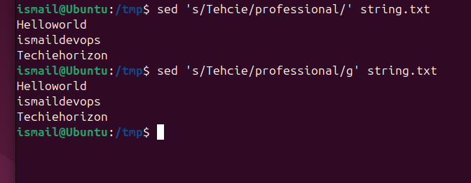

- Delete specific lines based on a pattern or line number.
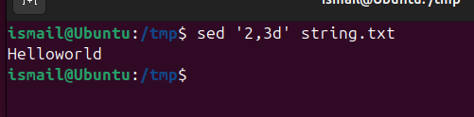

- Append or insert text before or after a specific pattern or line.
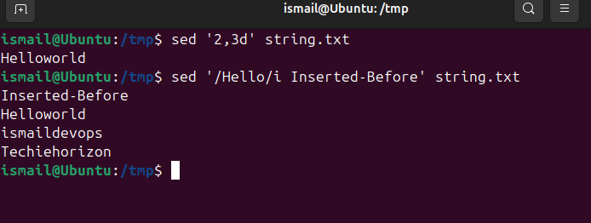
- Print only specific lines from a file.
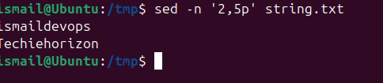

- Copy file from Linux to windows machine
I have installed file zila and we can drag and drop files as shown below.
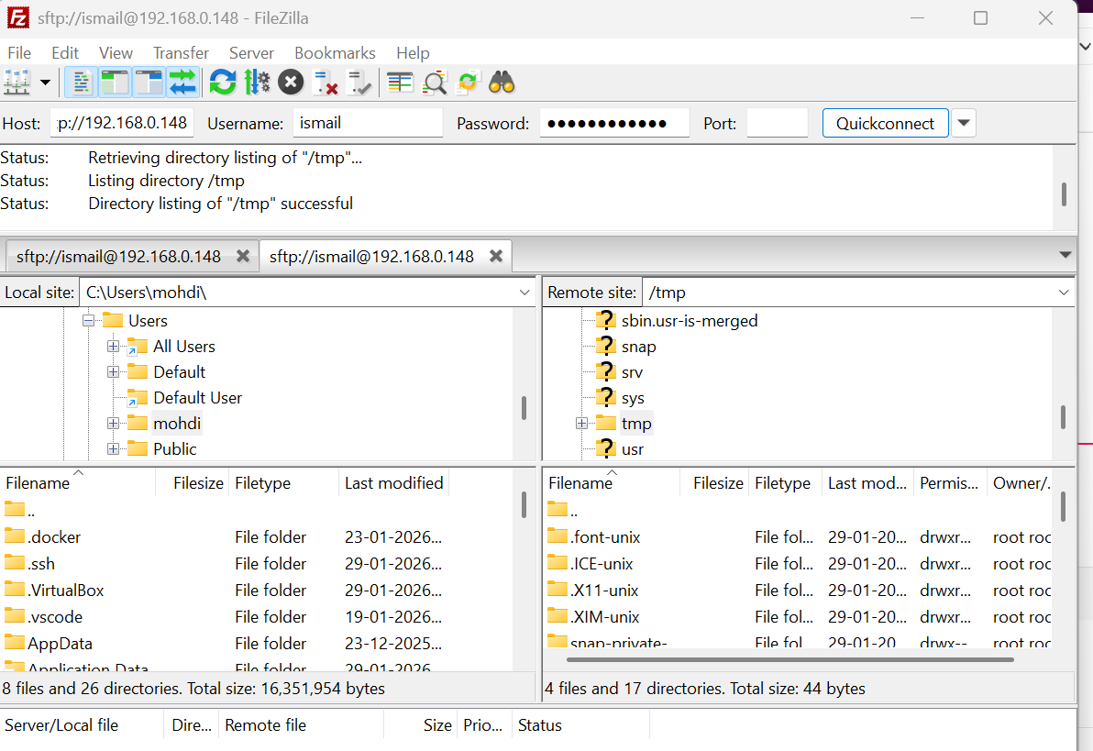
Winscp
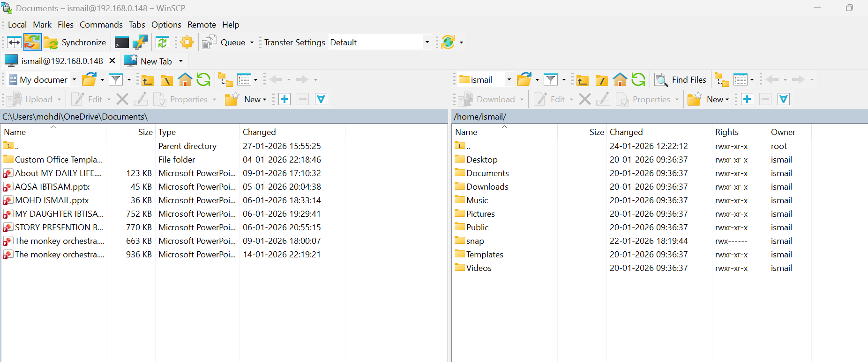

- use cases for AWK and 5 use cases for sed
